Local planning policy - WSUD in the Peel-Harvey catchment

This is a Local Planning Policy (LPP) prepared under Schedule 2 of the Planning and Development (Local Planning Schemes) Regulations 2015. This policy may be cited as “LPP x - WSUD in the Peel-Harvey catchment.”

Introduction

Purpose
This policy outlines key measures to apply water sensitive urban design (WSUD) principles within the Peel-Harvey Coastal Plain catchment (Figure 1) to support urban development that enhances water quality by reducing the amount of nutrients, sediment and other pollutants from washing into waterways.
This policy will contribute towards achieving the statutory environmental quality objectives specified in the Environmental Protection (Peel Inlet - Harvey Estuary) Policy 1992, and the associated water quality objectives outlined in the Gabi Warlang Bidi: Water quality improvement plan for the Peel-Harvey estuary system (DWER, 2025).
It complements State Planning Policy 2.9 Water, the Planning for Water Guidelines (WAPC, 2025) and State Planning Policy 2.1: The Peel Harvey Coastal Plain Catchment (WAPC, 2003).
It aligns with the Bindjareb Djilba (Peel-Harvey estuary) Protection Plan and seeks to ensure that when urban development occurs within the catchment, it contributes to the overall goal of improving water quality to safeguard the future health of the estuary.

Background information
Bindjareb Djilba, the Peel-Harvey estuary, is a vital ecological, cultural, and economic asset in south-western Australia. Its significant values are internationally recognised by its listing as a Ramsar wetland. Over the decades, the estuary has faced significant environmental pressures due to urban development, agricultural expansion and climate change. These pressures have led to nutrient pollution, habitat loss and ecological degradation, necessitating comprehensive management and protection strategies.
The Bindjareb Djilba (Peel-Harvey Estuary) Protection Plan is a whole-of-government initiative aimed at safeguarding the Peel-Harvey estuary's internationally recognised values. This plan emphasises a collaborative approach, involving government agencies, industry and the community to implement actions that improve water quality and protect the estuary's ecological, cultural, social, and economic values.
The Bindjareb Djilba (Peel-Harvey Estuary) Protection Plan is supported by the Gabi Warlang Bidi: Water Quality Improvement Plan for the Peel-Harvey estuary system.

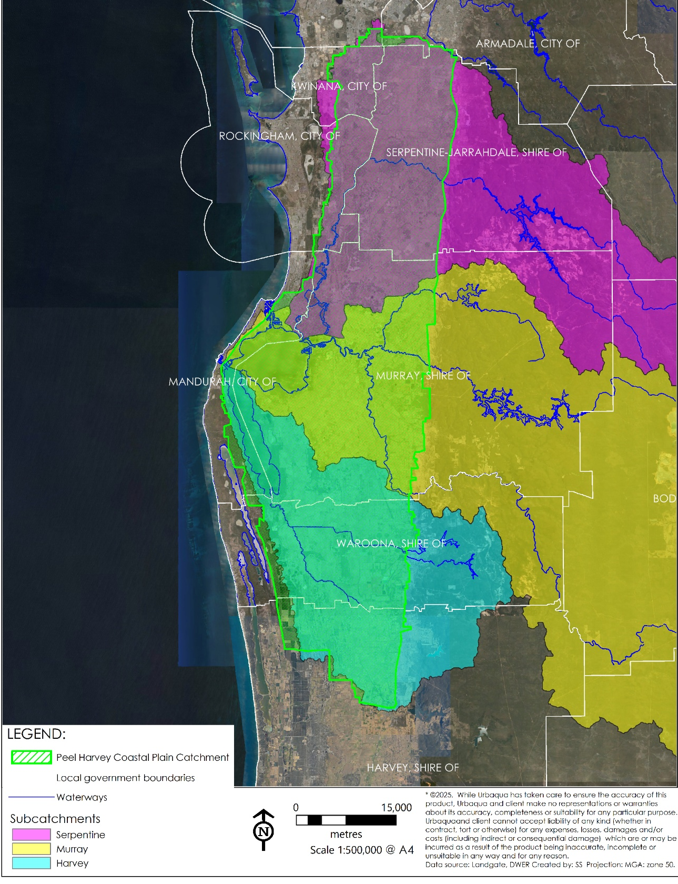
Figure 1: Peel Harvey Coastal Plain Catchment - area of policy application

Catchment characteristics and key issues
The internationally important Ramsar-listed landscape of the Peel-Harvey Estuary catchment poses significant challenges for drainage and urban development. These include soils that are poorly retentive for nutrients, flat landscapes and shallow groundwater. These conditions are further impacted by nutrient enrichment from agricultural runoff and urban land use. Hydrological modifications, such as drainage channels and irrigation systems, have altered natural water flow patterns, often leading to erosion and sedimentation. The clearing of native vegetation has reduced the landscape's natural filtration capacity, leading to increased runoff and nutrient leaching. Despite management efforts, maintaining water quality and managing nutrient loads remain ongoing challenges.
The values of the catchment are threatened further by the impacts of climate change and continued urban development. It is therefore critical that any development within the catchment implements the principles and practices of water sensitive urban design (WSUD).

Objectives
The objectives of the LPP are:
- To protect and improve the water quality of the Peel-Harvey Estuary by minimising future urban sources of nutrients to receiving environments as the area develops.
- To ensure sustainable management of stormwater and urban water resources in a manner that reflects local contexts.
- To enhance the resilience of urban areas to climate change impacts.

Application

Extent of scope
This policy applies to all new urban, industrial and commercial planning and development proposals within the Peel-Harvey catchment area as defined in the Environmental Protection (Peel Inlet - Harvey Estuary) Policy 1992 (Figure 1) and should be implemented as early as possible in the planning process and at all subsequent stages.. This includes all planning instruments such as scheme amendments, structure plans and proposals for subdivision and development. Water resource considerations should not be deferred if they are likely to pose significant issues that will become more difficult to resolve at subsequent planning stages.
It is not intended that this policy is applied to planning and development applications for areas zoned for rural purposes.

Relationship with State and local planning frameworks
This policy complements State Planning Policy 2.1: The Peel Harvey Coastal Plain Catchment (WAPC, 2003), State Planning Policy 2.9 Water and the Planning for Water Guidelines (WAPC, 2025). Is it expected that proponents consider this local policy and demonstrate how its requirements have been satisfied within the relevant Water Management Report as per State Planning Policy 2.9 Water.
It is to be read in conjunction with the following local policies (delete as required):
- City of Mandurah Water Sensitive Urban Design Policy, POL-RDS 07, created 2007, reviewed 2019
- Shire of Murray Local Planning Policy Water Sensitive Urban Design Policy, created 2007, reviewed 2018
- Shire of Serpentine Jarrahdale Local Planning Policy 2.4: Water Sensitive Urban Design Guidelines, replaced LPP6 WSD, adopted 2018, revised 2023
- Shire of Serpentine Jarrahdale Council Policy 2.1.10 – Energy and Water Efficiency, 2017
- Shire of Serpentine Jarrahdale Council Policy 2.1.8 - Water Supply – Domestic, 2017
- Stormwater Requirements for the Shire of Serpentine Jarrahdale, 2024
- Shire of Harvey Policy 5.1.3 – Road Reserves – Drainage, 1997, reviewed 2024
- Shire of Waroona IP008 – Stormwater Drainage, adopted 2004, reviewed 2021
- Shire of Waroona IP010 – Street and Reserve Trees, 2021

Policy Provisions

Design principles of WSUD
- Development should be designed to:
- enhance community and system resilience, amenity and liveability,
- mimic natural hydrological processes and ensure that the design of urban and built form is based on local site conditions and minimises changes to hydrology,
- manage, protect and restore wetlands, waterways and other natural systems,
- provide protection from flooding in 1% annual exceedance probability (AEP) flood event and surface or groundwater inundation/waterlogging.
- maximise water use efficiency and facilitate fit-for-purpose water sources including water reuse and recycling,
- minimise pollution inputs and outputs in surface water and groundwater flows and in receiving environments,
- create fit-for purpose, safe and sustainable water management systems that are integrated into the urban form, and
- enhance economic, social and cultural values of water resources.

Water quality management
- Development must incorporate WSUD solutions to reduce nutrient and pollutant loads entering the Peel-Harvey Estuary.
- To achieve the environmental quality objectives and the associated water quality objectives outlined in the Gabi Warlang Bidi: Water quality improvement plan for the Peel-Harvey estuary system (DWER, 2025) the following acceptable nutrient export rates are to be used to guide the design of water management systems:
  - An export rate for total phosphorous consistent with the relevant sub-catchment:
    - 0.29 kg/ha/year for sites in the Serpentine River sub-catchment;
    - 0.28 kg/ha/year for sites in the Murray River sub-catchment;
    - 0.47 kg/ha/year for sites in the Harvey sub-catchment.
  - An export rate of 2.4 kg/ha/year total nitrogen.
Demonstration of this requirement may be achieved through application of the Department of Water and Environmental Regulation’s Urban Nutrient Decision Outcomes (UNDO) tool (https://www.wa.gov.au/service/natural-resources/land-use-management/undo-tool).

Stormwater and drainage management
- Ensure that post-development stormwater discharge peak flows and top water levels do not exceed pre-development peak flows and top water levels in the following events:
  - Small events (1 exceedance per year).
  - Minor events (20% AEP event in residential areas, 10% AEP event in commercial and industrial areas).
  - Major events (1% AEP event).
- Ensure that post-development stormwater discharge volumes do not exceed pre-development volumes in small events (1 exceedance per year).
- Design and implement suitable erosion and sediment control measures at all discharge points into waterways and rural drains.
- Where the staging of construction of a drainage network is proposed, provide a clear description of the proposed temporary works, how these will function and how they are to be managed in future including transition.
- Implement erosion and sediment control measures at each construction site. This includes preparation of an erosion and sediment control plan that incorporates silt fences, sediment basins and other best management practices to prevent sediment from leaving the site and entering drainage systems and waterways.
- Development within a Rural Drainage District should seek to retain the rural drain and incorporate it into linear public open space as a living stream or swale and work with the local government to provide for its future management. The development should also be planned in accordance with the Water Corporation Information Sheet 59.
- Ensure stormwater management solutions do not create areas with standing water for longer than 96 hours.

Climate resilience
- Retain large trees and integrate vegetated stormwater assets into public open spaces, streetscapes and private developments to create opportunities for urban cooling and access to nature.
- Provide overland pathways for safe passage of runoff from extreme rainfall events.
- Identify and secure water sources for irrigation of new areas of public open space, noting that there is no further groundwater available for allocation across most of the area and alternative water sources will likely be required.

Collaborative delivery
- Engage with local and relevant stakeholders including the Bindjareb Noongar people to understand local values and demonstrate how the proposal responds to identified values. This should include local Traditional Owners such as those from local Aboriginal Corporations in addition to the relevant Prescribed Body Corporate.
- Consider multi-disciplinary design and review to optimise outcomes for the community.

Monitoring and maintenance
- Design water management systems to a level of service agreed with the local government and provide details of recommended maintenance activities including timing.
- Provide periodic reports detailing the performance of stormwater systems and any maintenance activities prior to handover of such systems to local government.

Glossary
Acceptable nutrient export rates | Maximum acceptable loads of nutrients (nitrogen and phosphorus) that can be discharged or runoff into waterways from a catchment without causing undesirable environmental impacts.
Environmental Quality Objectives | Management goals for the identified Environmental Values (the particular uses or values of a water body that are important for a healthy ecosystem or for public benefit) that reflect the desired water quality.
Peel-Harvey Coastal Plain Catchment | The land area on the Swan coastal plain that collects precipitation and flows via waterways (rivers, creeks, streams or brooks) and drains into the Peel-Harvey estuary
Water Quality Objectives | Guideline values (a measurable quantity, such as a concentration) for relevant indicators, or are narrative statements, which if met, support the management goals and the protection (or recovery) of community values.
Water Sensitive Urban Design | A planning and design approach that incorporates the sustainable management and integration of stormwater, groundwater, wastewater and water supply into the built form to achieve water and environmental outcomes as well as aesthetic/urban amenity, liveability, and urban cooling outcomes.

document control
Local Planning Policy – Document Control
Responsible Business Unit and/or Officer | Previous Policy Title  (if applicable) | Next Review Date
 |  | Should be no more than 5 years from date of adoption or last review
Version | Decision to Adopt/Amend | Brief Details of Modifications
1. | Meeting Date | Meeting Type | Item Number  Note: adoption/amendment and review dates should be in the dd/mm/yy e.g., 23/01/2024. | Not applicable - Version 1 should be the initial adoption of the policy.14 14 Guidance:
WAPC Approval Required  (Yes/No) | If yes, include a brief reason (refer to clause 4(3A) of the Regulations). | Date approved by the WAPC (if applicable)
Document Reference | For internal use

